

**Injecting Sub Types into Super Types.**

**Lab21: Files required**



|  |  |  |
| --- | --- | --- |
| **1.** | **Lab21.java** | **Same as Lab19** |
|  |  |  |
| **2.** | **A.java** | **Same as Lab19** |
|  |  |  |
| **3.** | **B.java** | **Same as Lab19** |
|  |  |  |
| **4.** | **CustomerDAO.java** | **Same as Lab19** |
|  |  |  |
| **5.** | **CustomerDAOImpl.java** | **Same as Lab19** |
|  |  |  |
| **6.** | **Hello.java** | **Same as Lab19** |
|  |  |  |
| **7.** | **JLCAppConfig.java** | **Updated in Lab21** |
|  |  |  |



1. **JLCAppConfig.java package com.coursecube.spring;**

**import org.springframework.beans.factory.annotation.Autowire; import org.springframework.context.annotation.Bean;**

**import org.springframework.context.annotation.Configuration; /\***

* **@Author : Srinivas Dande**
* **@Company : CourseCube**
* **@Website : www.coursecube.com**
* **\*/**

**@Configuration**

**public class JLCAppConfig {**

**@Bean(name="aobj")**

**public A createA() {**

**return new A();**

**}**

**@Bean(name="mybo")**

**public B createB() {**

**return new B();**

**}**

**@Bean(name="customerDAO")**

**public CustomerDAO getCustDAO() {**

**return new CustomerDAOImpl();**

**}**

**@Bean(name="myhello",autowire = Autowire.BY_NAME)**

**public Hello createHello() { //AutoWiring**

**return new Hello();**

**}**

**}**



**www.coursecube.com** **47** **Spring-5 Study Guide**



**Annotation based AutoWiring:**

**Field Injection can be implemented with Annotation based AutoWiring Field Injection :**

* **Injecting the Bean Dependencies directly without any Setter methods or Constructor is called Field Injection.**

**Using @Autowired:**

**@Autowired can be used in two ways.**

* 1. **ByType autowire process**
  2. **ByName autowire process**

1. **ByType autowiring with @Autowired**

**When you use @Autowired, then by default, beans will be detected based on byType autowire process and inject them directly without any Setter methods or Constructor.**

**A) @Autowired(required=true) / @Autowired**

**Case 1: What happens when 0 Matching Beans found.(Refer Lab22)**

**Exception will be thrown**

**NoSuchBeanDefinitionException: No qualifying bean of type 'com.coursecube.spring.Hai' available: which qualifies as autowire candidate. Dependency annotations: {Autowired(required=true)}**

**Case 2: What happens when exactly 1 Matching bean found.(Refer Lab23)**

**Identified single bean will be Injected Directly without any setter method.**

**Case 3: What happens when two or more Matching beans found.**

**If Any bean name is matching with local variable name then that will be injected with setter method.(Refer Lab24)**

**If Any bean name is not matching with local variable name then Exception will be thrown.(Ref.Lab25)**

**org.springframework.beans.factory.NoUniqueBeanDefinitionException: No qualifying bean of type 'com.coursecube.spring.Hai' available: expected single matching bean but found 3: myhai1,myhai2,myhai3**



**www.coursecube.com** **48** **Spring-5 Study Guide**



**Lab22: Files required**



|  |  |  |  |
| --- | --- | --- | --- |
| **1.** | **Lab22.java** | **2.** | **Hai.java** |
|  |  |  |  |
| **3.** | **Hello.java** | **4.** | **JLCAppConfig.java** |
|  |  |  |  |



**1. Lab22.java**

**package com.coursecube.spring;**

**import org.springframework.context.ApplicationContext;**

**import org.springframework.context.annotation.AnnotationConfigApplicationContext; /\***

* **@Author : Srinivas Dande**
* **@Company : CourseCube**
* **@Website : www.coursecube.com**
* **\*/**

**public class Lab22 {**

**public static void main(String[] args) {**

**ApplicationContext ctx=new AnnotationConfigApplicationContext(JLCAppConfig.class); System.out.println("---------Now Spring Container is Ready-----");**

**Hello hello=(Hello)ctx.getBean("myhello");**

**hello.show();**

**}**

**}**



**2. Hai.java**

**package com.coursecube.spring;**

**/\***

* **@Author : Srinivas Dande**
* **@Company : CourseCube**
* **@Website : www.coursecube.com**
* **\*/**

**public class Hai {**

**String msg;**

**public void setMsg(String msg) {**

**this.msg = msg;**

**}**

**public String toString() {**

**return msg;**

**}**

**}**



**www.coursecube.com** **49** **Spring-5 Study Guide**

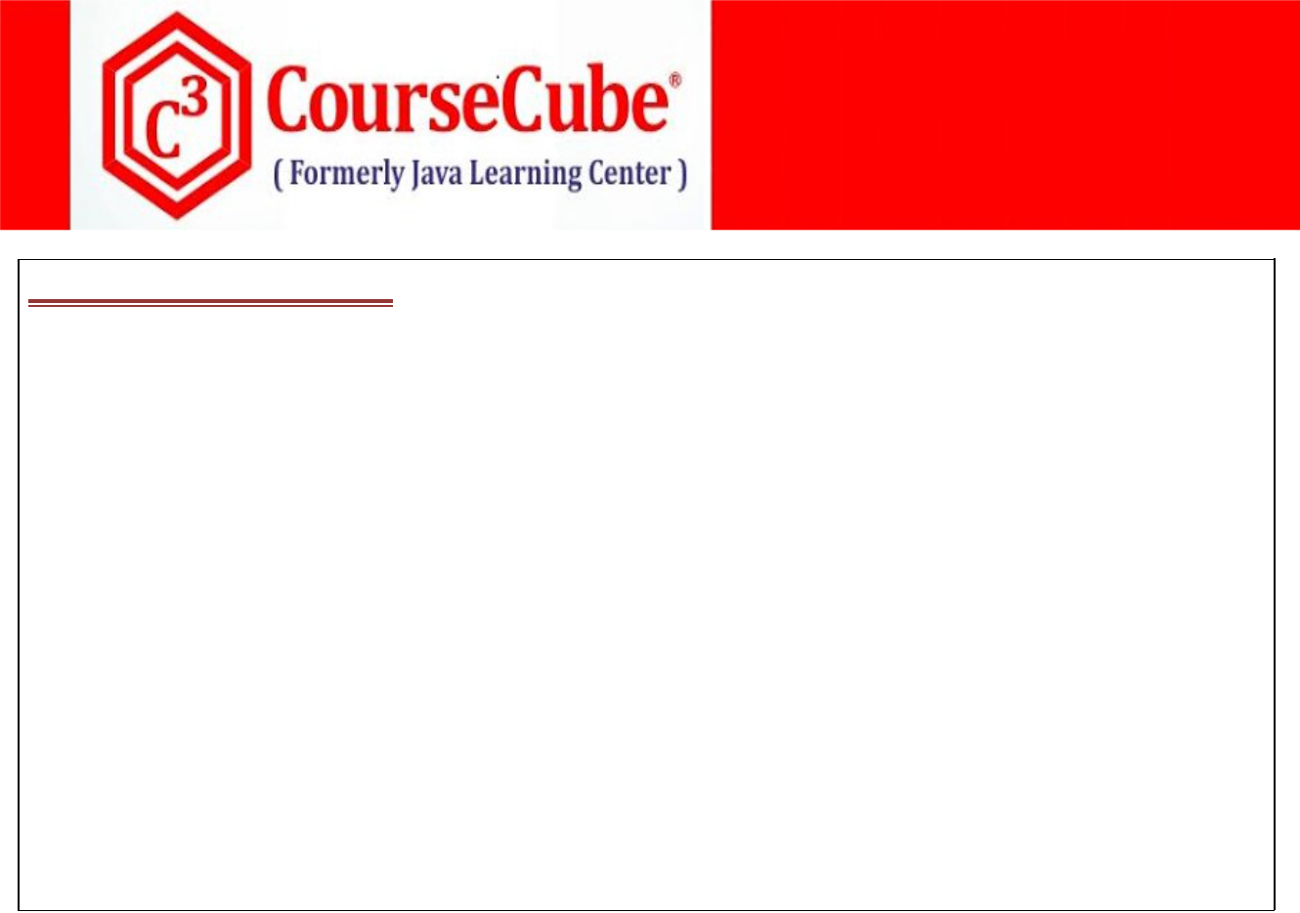

**3. Hello.java**

**package com.coursecube.spring;**

**import org.springframework.beans.factory.annotation.Autowired; /\***

* **@Author : Srinivas Dande**
* **@Company : CourseCube**
* **@Website : www.coursecube.com**
* **\*/**

**public class Hello {**

**@Autowired**

**Hai hai; //1**

**public void show() {**

**System.out.println(hai);**

**}**

**}**



1. **JLCAppConfig.java package com.coursecube.spring;**

**import org.springframework.context.annotation.Bean;**

**import org.springframework.context.annotation.Configuration; /\***

* **@Author : Srinivas Dande**
* **@Company : CourseCube**
* **@Website : www.coursecube.com**
* **\*/**

**@Configuration**

**public class JLCAppConfig {**

**@Bean(name="myhello")**

**public Hello createHello() {**

**return new Hello();**

**}**

**}**



**www.coursecube.com** **50** **Spring-5 Study Guide**



**Lab23: Files required**



|  |  |  |
| --- | --- | --- |
| **1.** | **Lab23.java** | **Same as Lab22** |
|  |  |  |
| **2.** | **Hai.java** | **Same as Lab22** |
|  |  |  |
| **3.** | **Hello.java** | **Same as Lab22** |
|  |  |  |
| **4.** | **JLCAppConfig.java** | **Updated in Lab23** |
|  |  |  |



1. **JLCAppConfig.java package com.coursecube.spring;**

**import org.springframework.context.annotation.Bean;**

**import org.springframework.context.annotation.Configuration;**

**/\***

* **@Author : Srinivas Dande**
* **@Company : CourseCube**
* **@Website : www.coursecube.com**
* **\*/**

**@Configuration**

**public class JLCAppConfig {**

**@Bean(name="myhai1")**

**public Hai createHai() {**

**Hai hai=new Hai();**

**hai.setMsg("I am Hai Bean 1");**

**return hai;**

**}**

**@Bean(name="myhello")**

**public Hello createHello() {**

**return new Hello();**

**}**

**}**



**www.coursecube.com** **51** **Spring-5 Study Guide**



**Lab24: Files required**



|  |  |  |
| --- | --- | --- |
| **1.** | **Lab24.java** | **Same as Lab22** |
|  |  |  |
| **2.** | **Hai.java** | **Same as Lab22** |
|  |  |  |
| **3.** | **Hello.java** | **Same as Lab22** |
|  |  |  |
| **4.** | **JLCAppConfig.java** | **Updated in Lab24** |
|  |  |  |



1. **JLCAppConfig.java package com.coursecube.spring;**

**import org.springframework.context.annotation.Bean;**

**import org.springframework.context.annotation.Configuration; /\***

* **@Author : Srinivas Dande**
* **@Company : CourseCube**
* **@Website : www.coursecube.com**
* **\*/**

**@Configuration**

**public class JLCAppConfig {**

**@Bean(name="myhai1")**

**public Hai createHai1() {**

**Hai hai=new Hai();**

**hai.setMsg("I am Hai Bean 1");**

**return hai;**

**}**

**@Bean(name="myhai2")**

**public Hai createHai2() {**

**Hai hai=new Hai();**

**hai.setMsg("I am Hai Bean 2");**

**return hai;**

**}**

**@Bean(name="hai")**

**public Hai createHai() {**

**Hai hai=new Hai();**

**hai.setMsg("I am also Hai Bean");**

**return hai;**

**}**

**@Bean(name="myhello")**

**public Hello createHello() {**

**return new Hello();**

**}**

**}**



**www.coursecube.com** **52** **Spring-5 Study Guide**



**Lab25: Files required**



|  |  |  |
| --- | --- | --- |
| **1.** | **Lab25.java** | **Same as Lab22** |
|  |  |  |
| **2.** | **Hai.java** | **Same as Lab22** |
|  |  |  |
| **3.** | **Hello.java** | **Same as Lab22** |
|  |  |  |
| **4.** | **JLCAppConfig.java** | **Updated in Lab25** |
|  |  |  |



1. **JLCAppConfig.java package com.coursecube.spring;**

**import org.springframework.context.annotation.Bean;**

**import org.springframework.context.annotation.Configuration; /\***

* **@Author : Srinivas Dande**
* **@Company : CourseCube**
* **@Website : www.coursecube.com**
* **\*/**

**@Configuration**

**public class JLCAppConfig {**

**@Bean(name="myhai1")**

**public Hai createHai1() {**

**Hai hai=new Hai();**

**hai.setMsg("I am Hai Bean 1");**

**return hai;**

**}**

**@Bean(name="myhai2")**

**public Hai createHai2() {**

**Hai hai=new Hai();**

**hai.setMsg("I am Hai Bean 2");**

**return hai;**

**}**

**@Bean(name="myhai3")**

**public Hai createHai() {**

**Hai hai=new Hai();**

**hai.setMsg("I am Hai Bean 3");**

**return hai;**

**}**

**@Bean(name="myhello")**

**public Hello createHello() {**

**return new Hello();**

**}**

**}**



**www.coursecube.com** **53** **Spring-5 Study Guide**



**B) @Autowired(required=false)**

**Case 1: What happens when 0 Matching Beans found.(Refer Lab26)**

**Bean Property remains Un-Injected.**

**Case 2: What happens when exactly 1 Matching bean found.(Refer Lab27)**

**Identified single bean will be Injected Directly without any setter method.**

**Case 3: What happens when two or more Matching beans found.**

**If Any bean name is matching with local variable name then that will be injected with setter method.(Refer Lab28)**

**If Any bean name is not matching with local variable name then Exception will be thrown.(Ref.Lab29)**

**org.springframework.beans.factory.NoUniqueBeanDefinitionException: No qualifying bean of type 'com.coursecube.spring.Hai' available: expected single matching bean but found 3: myhai1,myhai2,myhai3**

**Lab26: Files required**



|  |  |  |
| --- | --- | --- |
| **1.** | **Lab26.java** | **Same as Lab22** |
|  |  |  |
| **2.** | **Hai.java** | **Same as Lab22** |
|  |  |  |
| **3.** | **Hello.java** | **Updated in Lab26** |
|  |  |  |
| **4.** | **JLCAppConfig.java** | **Updated in Lab26** |
|  |  |  |



**3. Hello.java**

**package com.coursecube.spring;**

**import org.springframework.beans.factory.annotation.Autowired; /\***

* **@Author : Srinivas Dande**
* **@Company : CourseCube**
* **@Website : www.coursecube.com**
* **\*/**

**public class Hello {**

**@Autowired(required = false)**

**Hai hai; //1**

**public void show() {**

**System.out.println(hai);**

**}**

**}**



**www.coursecube.com** **54** **Spring-5 Study Guide**

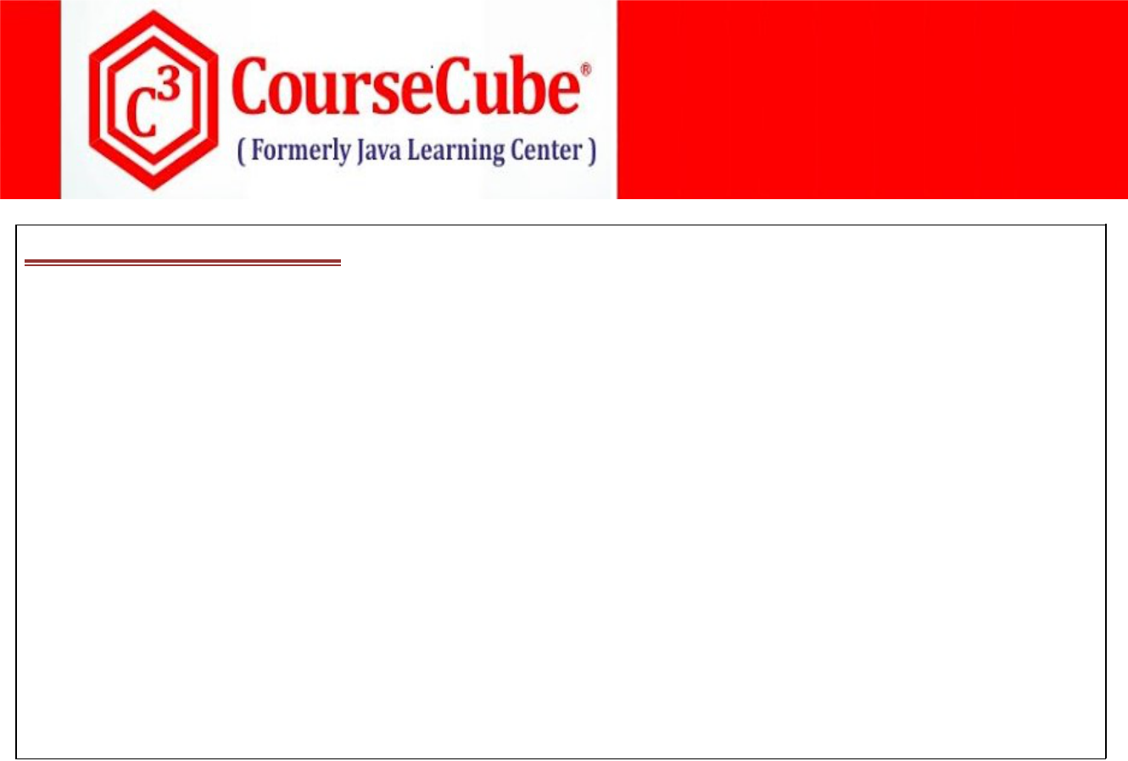

1. **JLCAppConfig.java package com.coursecube.spring;**

**import org.springframework.context.annotation.*;**

**/\***

* **@Author : Srinivas Dande**
* **@Company : CourseCube**
* **@Website : www.coursecube.com**
* **\*/**

**@Configuration**

**public class JLCAppConfig {**

**@Bean(name="myhello")**

**public Hello createHello() {**

**return new Hello();**

**}**

**}**

**Lab27: Files required**



|  |  |  |
| --- | --- | --- |
| **1.** | **Lab27.java** | **Same as Lab22** |
|  |  |  |
| **2.** | **Hai.java** | **Same as Lab22** |
|  |  |  |
| **3.** | **Hello.java** | **Updated in Lab27** |
|  |  |  |
| **4.** | **JLCAppConfig.java** | **Updated in Lab27** |
|  |  |  |



**3. Hello.java**

**package com.coursecube.spring;**

**import org.springframework.beans.factory.annotation.Autowired; /\***

* **@Author : Srinivas Dande**
* **@Company : CourseCube**
* **@Website : www.coursecube.com**
* **\*/**

**public class Hello {**

**@Autowired(required = false)**

**Hai hai; //1**

**public void show() {**

**System.out.println(hai);**

**}**

**}**



**www.coursecube.com** **55** **Spring-5 Study Guide**

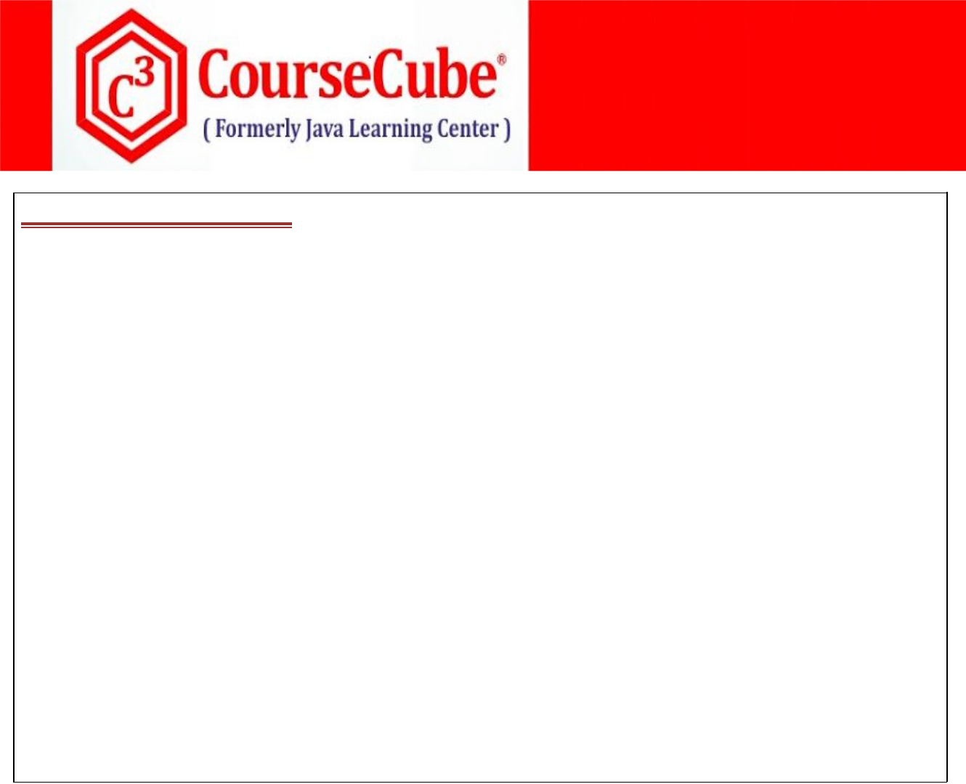

1. **JLCAppConfig.java package com.coursecube.spring;**

**import org.springframework.context.annotation.*;**

**/\***

* **@Author : Srinivas Dande**
* **@Company : CourseCube**
* **@Website : www.coursecube.com**
* **\*/**

**@Configuration**

**public class JLCAppConfig {**

**@Bean(name="myhai1")**

**public Hai createHai1() {**

**Hai hai=new Hai();**

**hai.setMsg("I am Hai Bean 1");**

**return hai;**

**}**

**@Bean(name="myhello")**

**public Hello createHello() {**

**return new Hello();**

**}**

**}**

**Lab28: Files required**



|  |  |  |
| --- | --- | --- |
| **5.** | **Lab28.java** | **Same Lab22** |
|  |  |  |
| **6.** | **Hai.java** | **Same Lab22** |
|  |  |  |
| **7.** | **Hello.java** | **Updated in Lab28** |
|  |  |  |
| **8.** | **JLCAppConfig.java** | **Updated in Lab28** |
|  |  |  |



**3. Hello.java**

**package com.coursecube.spring;**

**import org.springframework.beans.factory.annotation.Autowired; /\***

* **@Author : Srinivas Dande**
* **@Company : CourseCube**
* **@Website : www.coursecube.com**
* **\*/**

**public class Hello {**

**@Autowired(required = false)**

**Hai hai; //1**

**public void show() {**

**System.out.println(hai);**

**}**

**}**



**www.coursecube.com** **56** **Spring-5 Study Guide**



1. **JLCAppConfig.java package com.coursecube.spring;**

**import org.springframework.context.annotation.Bean;**

**import org.springframework.context.annotation.Configuration; /\***

* **@Author : Srinivas Dande**
* **@Company : CourseCube**
* **@Website : www.coursecube.com**
* **\*/**

**@Configuration**

**public class JLCAppConfig {**

**@Bean(name="myhai1")**

**public Hai createHai1() {**

**Hai hai=new Hai();**

**hai.setMsg("I am Hai Bean 1");**

**return hai;**

**}**

**@Bean(name="myhai2")**

**public Hai createHai2() {**

**Hai hai=new Hai();**

**hai.setMsg("I am Hai Bean 2");**

**return hai;**

**}**

**@Bean(name="hai")**

**public Hai createHai() {**

**Hai hai=new Hai();**

**hai.setMsg("I am also Hai Bean");**

**return hai;**

**}**

**@Bean(name="myhello")**

**public Hello createHello() {**

**return new Hello();**

**}**

**}**



**www.coursecube.com** **57** **Spring-5 Study Guide**



**Lab29: Files required**



|  |  |  |
| --- | --- | --- |
| **1.** | **Lab29.java** | **Same Lab22** |
|  |  |  |
| **2.** | **Hai.java** | **Same Lab22** |
|  |  |  |
| **3.** | **Hello.java** | **Updated in Lab29** |
|  |  |  |
| **4.** | **JLCAppConfig.java** | **Updated in Lab29** |
|  |  |  |



**3. Hello.java**

**package com.coursecube.spring;**

**import org.springframework.beans.factory.annotation.Autowired; /\***

* **@Author : Srinivas Dande**
* **@Company : CourseCube**
* **@Website : www.coursecube.com**
* **\*/**

**public class Hello {**

**@Autowired(required = false)**

**Hai hai; //1**

**public void show() {**

**System.out.println(hai);**

**}**

**}**



1. **JLCAppConfig.java package com.coursecube.spring;**

**import org.springframework.context.annotation.Bean;**

**import org.springframework.context.annotation.Configuration; /\***

* **@Author : Srinivas Dande**
* **@Company : CourseCube**
* **@Website : www.coursecube.com**
* **\*/**

**@Configuration**

**public class JLCAppConfig {**

**@Bean(name="myhai1")**

**public Hai createHai1() {**

**Hai hai=new Hai();**

**hai.setMsg("I am Hai Bean 1");**

**return hai;**

**}**



**www.coursecube.com** **58** **Spring-5 Study Guide**

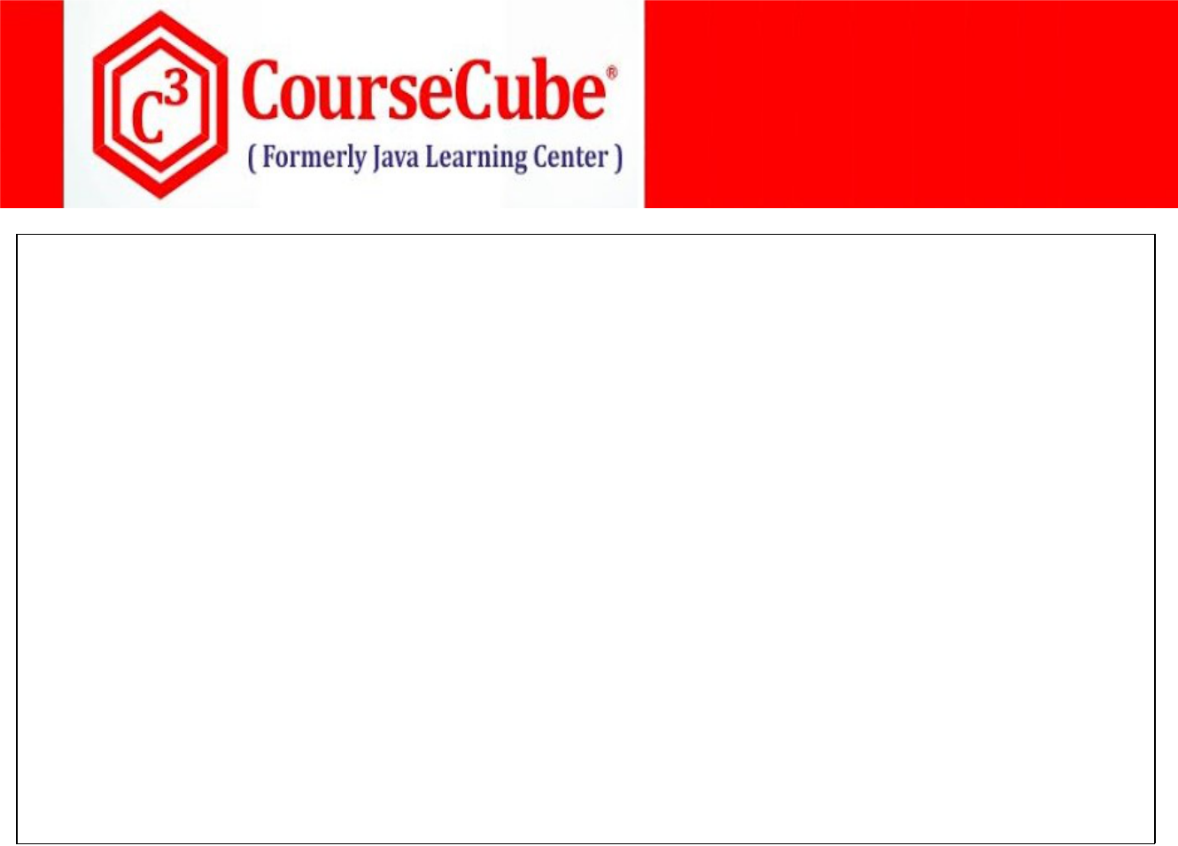

**@Bean(name="myhai2")**

**public Hai createHai2() {**

**Hai hai=new Hai();**

**hai.setMsg("I am Hai Bean 2");**

**return hai;**

**}**

**@Bean(name="myhai3")**

**public Hai createHai() {**

**Hai hai=new Hai();**

**hai.setMsg("I am Hai Bean 3");**

**return hai;**

**}**

**@Bean(name="myhello")**

**public Hello createHello() {**

**return new Hello();**

**}**

**}**

1. **ByName autowiring with @Autowired**

**When you want to detect the beans based on byName autowire process then you need to use @Qualifier Annotation along with @Autowired.**

**A) @Autowired(required=true) / @Autowired**

**@Autowired(required=true)**

**@Qualifier("myhai")**

**Case 1: What happens when 0 Matching Beans found.(Refer Lab30)**

**Exception will be thrown**

**NoSuchBeanDefinitionException: No qualifying bean of type 'com.coursecube.spring.Hai' available: which qualifies as autowire candidate. Dependency annotations: {Autowired(required=true)}**

**Case 2: What happens when exactly 1 Matching bean found.(Refer Lab31)**

**Identified single bean will be Injected Directly without any setter method.**



**www.coursecube.com** **59** **Spring-5 Study Guide**



**Lab30: Files required**



|  |  |  |
| --- | --- | --- |
| **1.** | **Lab30.java** | **Same Lab22** |
|  |  |  |
| **2.** | **Hai.java** | **Same Lab22** |
|  |  |  |
| **3.** | **Hello.java** | **Updated in Lab30** |
|  |  |  |
| **4.** | **JLCAppConfig.java** | **Updated in Lab30** |
|  |  |  |



**3. Hello.java**

**package com.coursecube.spring;**

**import org.springframework.beans.factory.annotation.*; /\***

* **@Author : Srinivas Dande**
* **@Company : CourseCube**
* **@Website : www.coursecube.com**
* **\*/**

**public class Hello {**

**@Autowired**

**@Qualifier("myhai")**

**Hai hai; //1**

**public void show() {**

**System.out.println(hai);**

**}**

**}**



1. **JLCAppConfig.java package com.coursecube.spring;**

**import org.springframework.context.annotation.Bean;**

**import org.springframework.context.annotation.Configuration; /\***

* **@Author : Srinivas Dande**
* **@Company : CourseCube**
* **@Website : www.coursecube.com**
* **\*/**

**@Configuration**

**public class JLCAppConfig {**

**@Bean(name="myhello")**

**public Hello createHello() {**

**return new Hello();**

**}**

**}**



**www.coursecube.com** **60** **Spring-5 Study Guide**



**Lab31: Files required**



|  |  |  |
| --- | --- | --- |
| **1.** | **Lab31.java** | **Same Lab22** |
|  |  |  |
| **2.** | **Hai.java** | **Same Lab22** |
|  |  |  |
| **3.** | **Hello.java** | **Updated in Lab31** |
|  |  |  |
| **4.** | **JLCAppConfig.java** | **Updated in Lab31** |
|  |  |  |



**3. Hello.java**

**package com.coursecube.spring;**

**import org.springframework.beans.factory.annotation.*; /\***

* **@Author : Srinivas Dande**
* **@Company : CourseCube**
* **@Website : www.coursecube.com**
* **\*/**

**public class Hello {**

**@Autowired**

**@Qualifier("myhai")**

**Hai hai; //1**

**public void show() {**

**System.out.println(hai);**

**}**

**}**



1. **JLCAppConfig.java package com.coursecube.spring;**

**import org.springframework.context.annotation.*;**

**/\***

* **@Author : Srinivas Dande**
* **@Company : CourseCube**
* **@Website : www.coursecube.com**
* **\*/**

**@Configuration**

**public class JLCAppConfig {**

**@Bean(name="myhai")**

**public Hai createHai1() {**

**Hai hai=new Hai();**

**hai.setMsg("I am Hai Bean 1");**

**return hai;**

**}**

**@Bean(name="myhello")**

**public Hello createHello() {**

**return new Hello();**

**}**

**}**



**www.coursecube.com** **61** **Spring-5 Study Guide**



1. **@Autowired(required=false)**
   1. **@Autowired(required=false)**

**@Qualifier("myhai")**

**Case 1: What happens when 0 Matching Beans found.(Refer Lab32)**

**Bean Property remains Un-Injected.**

**Case 2: What happens when exactly 1 Matching bean found.(Refer Lab33)**

**Identified single bean will be Injected Directly without any setter method.**

**Lab32: Files required**



|  |  |  |
| --- | --- | --- |
| **5.** | **Lab32.java** | **Same Lab22** |
|  |  |  |
| **6.** | **Hai.java** | **Same Lab22** |
|  |  |  |
| **7.** | **Hello.java** | **Updated in Lab32** |
|  |  |  |
| **8.** | **JLCAppConfig.java** | **Updated in Lab32** |
|  |  |  |



**3. Hello.java**

**package com.coursecube.spring;**

**import org.springframework.beans.factory.annotation.*; /\***

* **@Author : Srinivas Dande**
* **@Company : CourseCube**
* **@Website : www.coursecube.com**
* **\*/**

**public class Hello {**

**@Autowired(required=false)**

**@Qualifier("myhai")**

**Hai hai; //1**

**public void show() {**

**System.out.println(hai);**

**}**

**}**



**www.coursecube.com** **62** **Spring-5 Study Guide**



1. **JLCAppConfig.java package com.coursecube.spring;**

**import org.springframework.context.annotation.Bean;**

**import org.springframework.context.annotation.Configuration; /\***

* **@Author : Srinivas Dande**
* **@Company : CourseCube**
* **@Website : www.coursecube.com**
* **\*/**

**@Configuration**

**public class JLCAppConfig {**

**@Bean(name="myhello")**

**public Hello createHello() {**

**return new Hello();**

**}**

**}**

**Lab33: Files required**



|  |  |  |
| --- | --- | --- |
| **5.** | **Lab33.java** | **Same Lab22** |
|  |  |  |
| **6.** | **Hai.java** | **Same Lab22** |
|  |  |  |
| **7.** | **Hello.java** | **Updated in Lab33** |
|  |  |  |
| **8.** | **JLCAppConfig.java** | **Updated in Lab33** |
|  |  |  |



**3. Hello.java**

**package com.coursecube.spring;**

**import org.springframework.beans.factory.annotation.*; /\***

* **@Author : Srinivas Dande**
* **@Company : CourseCube**
* **@Website : www.coursecube.com**
* **\*/**

**public class Hello {**

**@Autowired(required=false)**

**@Qualifier("myhai")**

**Hai hai; //1**

**public void show() {**

**System.out.println(hai);**

**}**

**}**



**www.coursecube.com** **63** **Spring-5 Study Guide**



1. **JLCAppConfig.java package com.coursecube.spring;**

**import org.springframework.context.annotation.*; /\***

* **@Author : Srinivas Dande**
* **@Company : CourseCube**
* **@Website : www.coursecube.com**
* **\*/**

**@Configuration**

**public class JLCAppConfig {**

**@Bean(name="myhai")**

**public Hai createHai1() {**

**Hai hai=new Hai();**

**hai.setMsg("I am Hai Bean 1");**

**return hai;**

**}**

**@Bean(name="myhello")**

**public Hello createHello() {**

**return new Hello();**

**}**

**}**

**Using @Autowired for Setter Methods**

**You can use @Autowired for setter methods, then beans will be injected withSetter methods**

**@Autowired can be used for setter methods in two ways.**

**1) @Autowired(required=true)** **(Refer Lab34)**

**@Autowired**

**public void setAobj(A aobj) {**

**this.aobj = aobj;**

**}**

**2) @Autowired(required=false)** **(Refer Lab35)**

**@Autowired(required=false)**

**public void setAobj(A aobj) {**

**this.aobj = aobj;**

**}**



**www.coursecube.com** **64** **Spring-5 Study Guide**



**Lab34: Files required**

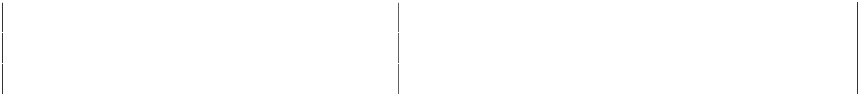

|  |  |  |  |
| --- | --- | --- | --- |
| **1.** | **Lab34.java** | **2.** | **A.java** |
|  |  |  |  |
| **3.** | **B.java** | **4.** | **Hai.java** |
|  |  |  |  |
| **5.** | **Hello.java** | **6.** | **JLCAppConfig.java** |
|  |  |  |  |



**1. Lab34.java**

**package com.coursecube.spring;**

**import org.springframework.context.ApplicationContext;**

**import org.springframework.context.annotation.AnnotationConfigApplicationContext; /\***

* **@Author : Srinivas Dande**
* **@Company : CourseCube**
* **@Website : www.coursecube.com**
* **\*/**

**public class Lab34 {**

**public static void main(String[] args) {**

**ApplicationContext ctx=new AnnotationConfigApplicationContext(JLCAppConfig.class); System.out.println("---------Now Spring Container is Ready-----");**

**Hello hello=(Hello)ctx.getBean("myhello");**

**hello.show();**

**}**

**}**



**2. A.java**

**package com.coursecube.spring;**

**/\***

* **@Author : Srinivas Dande**
* **@Company : CourseCube**
* **@Website : www.coursecube.com**
* **\*/**

**public class A {**

**String msg; //S.I**

**public void setMsg(String msg) {**

**System.out.println("A - setMsg()");**

**this.msg=msg;**

**}**

**public String toString() {**

**return msg;**

**}**

**}**



**www.coursecube.com** **65** **Spring-5 Study Guide**



**3. B.java**

**package com.coursecube.spring;**

**/\***

* **@Author : Srinivas Dande**
* **@Company : CourseCube**
* **@Website : www.coursecube.com**
* **\*/**

**public class B {**

**String str; //C.I**

**public B( String str) {**

**System.out.println("B -1 arg");**

**this.str = str;**

**}**

**public String toString() {**

**return str;**

**}**

**}**



**4. Hai.java**

**package com.coursecube.spring;**

**/\***

* **@Author : Srinivas Dande**
* **@Company : CourseCube**
* **@Website : www.coursecube.com**
* **\*/**

**public class Hai {**

**String msg; //Dependency**

**public void setMsg(String msg) {**

**this.msg = msg;**

**}**

**public String toString() {**

**return msg;**

**}**

**}**



**5. Hello.java**

**package com.coursecube.spring;**

**import org.springframework.beans.factory.annotation.Autowired; /\***

* **@Author : Srinivas Dande**
* **@Company : CourseCube**
* **@Website : www.coursecube.com**
* **\*/**



**www.coursecube.com** **66** **Spring-5 Study Guide**

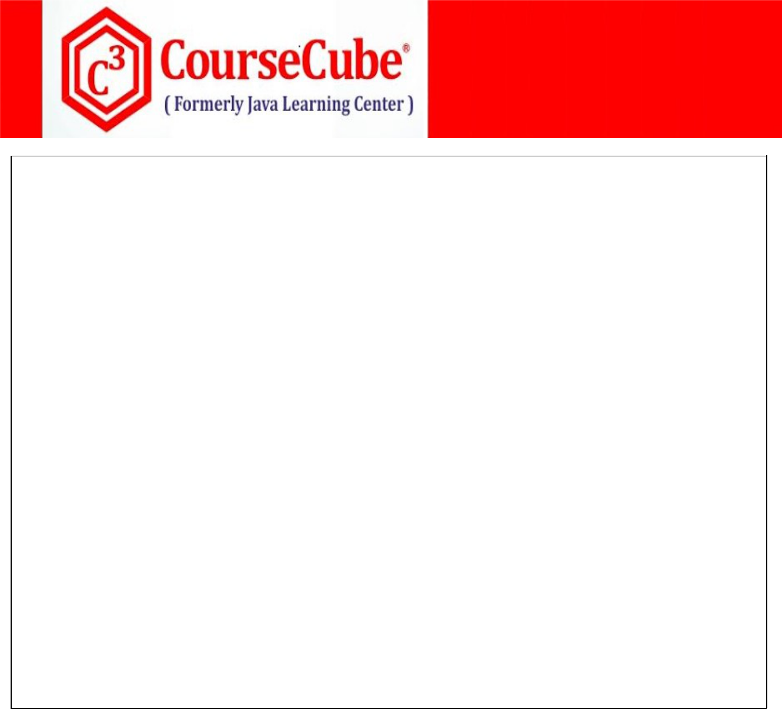

**public class Hello {**

**@Autowired**

**private Hai hai; //Field Injection**

**private A aobj; //Setter Injection**

**private B bobj; //Setter Injection**

**@Autowired**

**public void setAobj(A aobj) {**

**System.out.println("Hello-setAobj()");**

**this.aobj = aobj;**

**}**

**@Autowired**

**public void setBobj(B bobj) {**

**System.out.println("Hello-setBobj()");**

**this.bobj = bobj;**

**}**

**public void show() {**

**System.out.println("Hello-show()");**

**System.out.println(hai);**

**System.out.println(aobj);**

**System.out.println(bobj);**

**}**

**}**



1. **JLCAppConfig.java package com.coursecube.spring;**

**import org.springframework.context.annotation.*; /\***

* **@Author : Srinivas Dande**
* **@Company : CourseCube**
* **@Website : www.coursecube.com**
* **\*/**

**@Configuration**

**public class JLCAppConfig {**

**@Bean(name="myhai")**

**public Hai createHai() {**

**Hai hai=new Hai();**

**hai.setMsg("I am Hai Bean");**

**return hai;**

**}**



**www.coursecube.com** **67** **Spring-5 Study Guide**

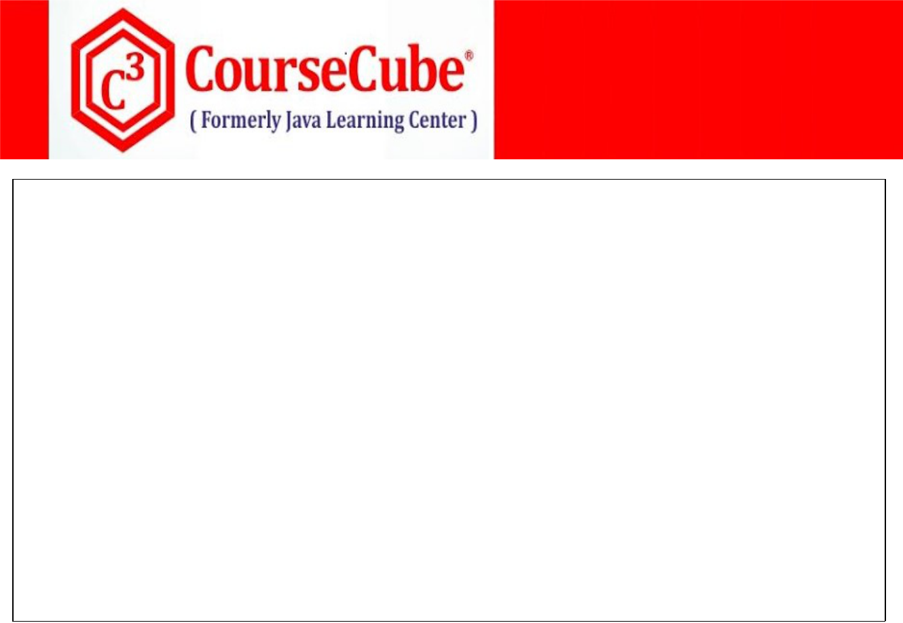

**@Bean(name="myao")**

**public A createA() {**

**A ao=new A();**

**ao.setMsg("I am Bean - A");**

**return ao;**

**}**

**@Bean(name="mybo")**

**public B createB() {**

**B bo=new B("I am Bean - B");**

**return bo;**

**}**

**@Bean(name="myhello")**

**public Hello createHello() {**

**return new Hello();**

**}**

**}**

**Lab35: Files required**



|  |  |  |
| --- | --- | --- |
| **1.** | **Lab35.java** | **Same as Lab34** |
|  |  |  |
| **2.** | **A.java** | **Same as Lab34** |
|  |  |  |
| **3.** | **B.java** | **Same as Lab34** |
|  |  |  |
| **4.** | **Hai.java** | **Same as Lab34** |
|  |  |  |
| **5.** | **Hello.java** | **Updated in Lab35** |
|  |  |  |
| **6.** | **JLCAppConfig.java** | **Updated in Lab35** |
|  |  |  |



**5. Hello.java**

**package com.coursecube.spring;**

**import org.springframework.beans.factory.annotation.Autowired; /\***

* **@Author : Srinivas Dande**
* **@Company : CourseCube**
* **@Website : www.coursecube.com**
* **\*/**

**public class Hello {**

**@Autowired**

**private Hai hai; //Field Injection**

**private A aobj; //Setter Injection**

**private B bobj; //Setter Injection**

**@Autowired (required=false)**

**public void setAobj(A aobj) {**

**System.out.println("Hello-setAobj()");**

**this.aobj = aobj;**

**}**



**www.coursecube.com** **68** **Spring-5 Study Guide**

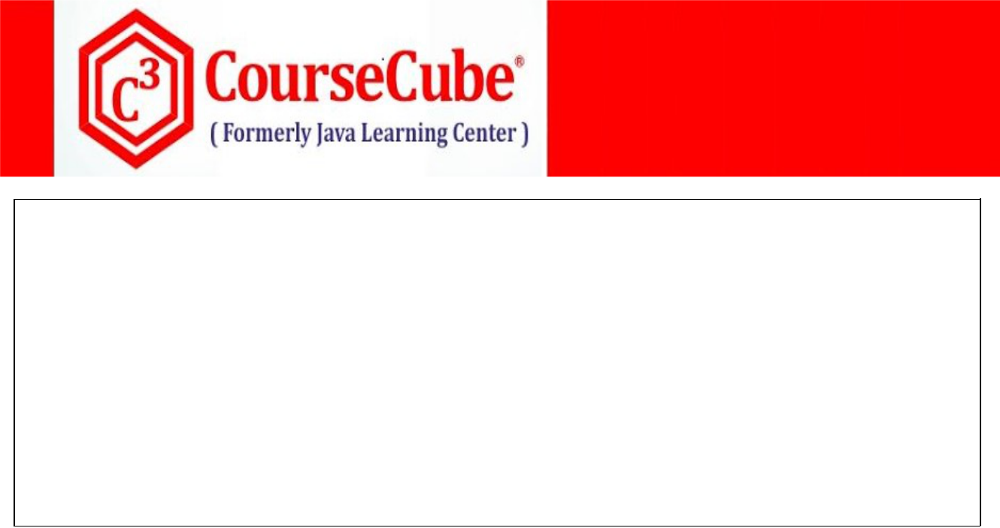

**@Autowired (required=false)**

**public void setBobj(B bobj) {**

**System.out.println("Hello-setBobj()");**

**this.bobj = bobj;**

**}**

**public void show() {**

**System.out.println("Hello-show()");**

**System.out.println(hai);**

**System.out.println(aobj);**

**System.out.println(bobj);**

**}**

**}**



1. **JLCAppConfig.java package com.coursecube.spring;**

**import org.springframework.context.annotation.*; /\***

* **@Author : Srinivas Dande**
* **@Company : CourseCube**
* **@Website : www.coursecube.com**
* **\*/**

**@Configuration**

**public class JLCAppConfig {**

**@Bean(name="myhai")**

**public Hai createHai() {**

**Hai hai=new Hai();**

**hai.setMsg("I am Hai Bean");**

**return hai;**

**}**

**@Bean(name="myhello")**

**public Hello createHello() {**

**return new Hello();**

**}**

**}**



**www.coursecube.com** **69** **Spring-5 Study Guide**



**Using JSR-250 Annotations**

**Following annotations provided in javax.annotation package**

* 1. **@PostConstructinit()**
  2. **@PreDestroydestroy()**
  3. **@Resource**

**Note:**

**When you want to use JSR-250 Annotations you must add javaee.jar file to project build path.**

1. **@PostConstruct:**

**You can mark the method with @PostConstruct Annotation. Method which is marked with @PostConstruct Annotation**

* + - **will be called by the Spring Container after creating Bean Instance**
    - **contains the code for initializing bean instance with the required resources.**

1. **@PreDestroy:**

**You can mark the method with @ PreDestroy Annotation. Method which is marked with @ PreDestroy Annotation**

* + - **will be called by the Spring Container before destroying Bean Instance**
    - **contains the code for cleaning resources initialized with bean instance.**

1. **@Resource:**

**You can mark the Bean Property with @Resource Annotation.**

**When you use @Resource, then beans will be detected either based on byName or byType process and injects them.**

* + - **When name attribute is specified for @Resource then uses byName autowire process. (Refer Lab36)**
    - **When name attribute is not specified for @Resource then uses byType autowire process. (Refer Lab37)**

**Lab36: Files required**



|  |  |  |
| --- | --- | --- |
| **1.** | **Lab36.java** | **Same Lab22** |
|  |  |  |
| **2.** | **Hai.java** | **Same Lab22** |
|  |  |  |
| **3.** | **Hello.java** | **Updated in Lab36** |
|  |  |  |
| **4.** | **JLCAppConfig.java** | **Updated in Lab36** |
|  |  |  |



**3. Hello.java**

**package com.coursecube.spring;**

**import javax.annotation.Resource;**

**/\***

* **@Author : Srinivas Dande**
* **@Company : CourseCube**
* **@Website : www.coursecube.com**
* **\*/**



**www.coursecube.com** **70** **Spring-5 Study Guide**

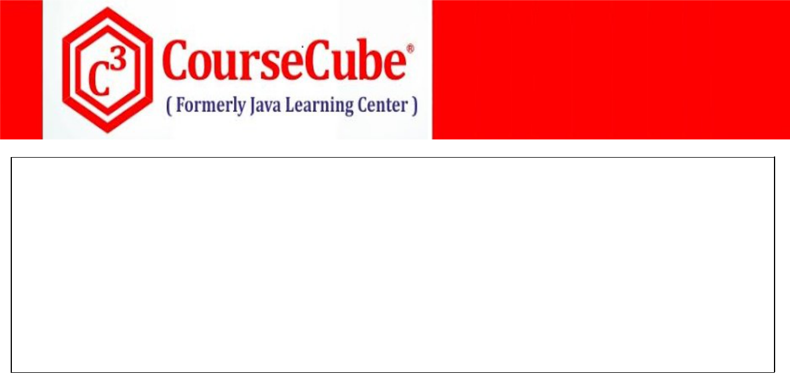

**public class Hello {**

**@Resource //ByType(Default)**

**Hai hai;** **//Field Injection**

**public void show() {**

**System.out.println("Hello-show()");**

**System.out.println(hai);**

**}**

**}**



1. **JLCAppConfig.java package com.coursecube.spring;**

**import org.springframework.context.annotation.*;**

**/\***

* **@Author : Srinivas Dande**
* **@Company : CourseCube**
* **@Website : www.coursecube.com**
* **\*/**

**@Configuration**

**public class JLCAppConfig {**

**@Bean(name="myhai")**

**public Hai createHai1() {**

**Hai hai=new Hai();**

**hai.setMsg("I am Hai Bean 1");**

**return hai;**

**}**

**@Bean(name="myhello")**

**public Hello createHello() {**

**return new Hello();**

**}**

**}**

**Lab37: Files required**



|  |  |  |
| --- | --- | --- |
| **1.** | **Lab37.java** | **Same Lab22** |
|  |  |  |
| **2.** | **Hai.java** | **Same Lab22** |
|  |  |  |
| **3.** | **Hello.java** | **Updated in Lab37** |
|  |  |  |
| **4.** | **JLCAppConfig.java** | **Updated in Lab37** |
|  |  |  |

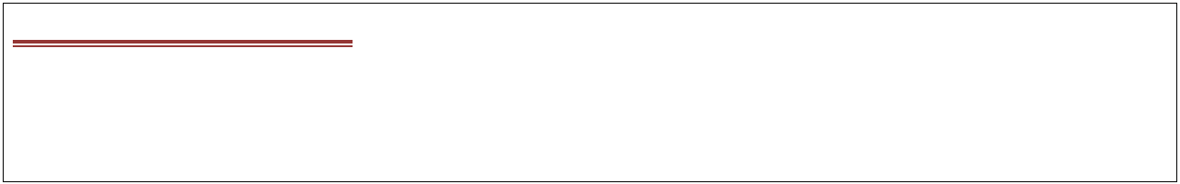

**3. Hello.java**

**package com.coursecube.spring;**

**import javax.annotation.Resource;**

**/\***



**www.coursecube.com** **71** **Spring-5 Study Guide**



* **@Author : Srinivas Dande**
* **@Company : CourseCube**
* **@Website : www.coursecube.com**
* **\*/**

**public class Hello {**

**@Resource(name="myhai2") //ByName**

**Hai hai;** **//Field Injection**

**public void show() {**

**System.out.println("Hello-show()");**

**System.out.println(hai);**

**}**

**}**



1. **JLCAppConfig.java package com.coursecube.spring;**

**import org.springframework.context.annotation.*; /\***

* **@Author : Srinivas Dande**
* **@Company : CourseCube**
* **@Website : www.coursecube.com**
* **\*/**

**@Configuration**

**public class JLCAppConfig {**

**@Bean(name="myhai1")**

**public Hai createHai1() {**

**Hai hai=new Hai();**

**hai.setMsg("I am Hai Bean 1");**

**return hai;**

**}**

**@Bean(name="myhai2")**

**public Hai createHai2() {**

**Hai hai=new Hai();**

**hai.setMsg("I am Hai Bean 2");**

**return hai;**

**}**

**@Bean(name="myhello")**

**public Hello createHello() {**

**return new Hello();**

**}**

**}**



**www.coursecube.com** **72** **Spring-5 Study Guide**



**@Inject**

**When you use @Inject, then by default, beans will be detected based on byType process and inject them directly without any Stetter methods or Constructor.**

**When you want to detect the beans based on byName process then you need to @Qualifier Annotation along with @Inject.**

**Note: When you want to use @Inject Annotation then you must add javax.inject.jar file to project build path.**

**Lab38: Files required**



|  |  |  |  |
| --- | --- | --- | --- |
| **1.** | **Lab38.java** | **2.** | **A.java** |
|  |  |  |  |
| **3.** | **Hai.java** | **4.** | **Hello.java** |
|  |  |  |  |
| **5.** | **JLCAppConfig.java** |  |  |
|  |  |  |  |



**1. Lab38.java**

**package com.coursecube.spring;**

**import org.springframework.context.ApplicationContext;**

**import org.springframework.context.annotation.AnnotationConfigApplicationContext; /\***

* **@Author : Srinivas Dande**
* **@Company : CourseCube**
* **@Website : www.coursecube.com**
* **\*/**

**public class Lab38 {**

**public static void main(String[] args) {**

**ApplicationContext ctx=new AnnotationConfigApplicationContext(JLCAppConfig.class); System.out.println("---------Now Spring Container is Ready-----"); Hello hello=(Hello)ctx.getBean("myhello");**

**hello.show();**

**}**

**}**



**2. A.java**

**package com.coursecube.spring;**

**public class A {**

**String str; //Dependency**

**public void setStr(String str) {**

**this.str = str;**

**}**

**public String toString() {**

**return str;**

**}**

**}**



**www.coursecube.com** **73** **Spring-5 Study Guide**



**3. Hai.java**

**package com.coursecube.spring;**

**/\***

* **@Author : Srinivas Dande**
* **@Company : CourseCube**
* **@Website : www.coursecube.com**
* **\*/**

**public class Hai {**

**String msg; //Dependency**

**public void setMsg(String msg) {**

**this.msg = msg;**

**}**

**public String toString() {**

**return msg;**

**}**

**}**



**4. Hello.java**

**package com.coursecube.spring;**

**import javax.inject.Inject;**

**import org.springframework.beans.factory.annotation.Qualifier; /\***

* **@Author : Srinivas Dande**
* **@Company : CourseCube**
* **@Website : www.coursecube.com**
* **\*/**

**public class Hello {**

**@Inject**

**Hai hai; //ByType**

**@Inject**

**@Qualifier("myao")**

**A aobj; //ByName**

**public void show() {**

**System.out.println("Hello-show()");**

**System.out.println(hai);**

**System.out.println(aobj);**

**}**

**}**



**www.coursecube.com** **74** **Spring-5 Study Guide**

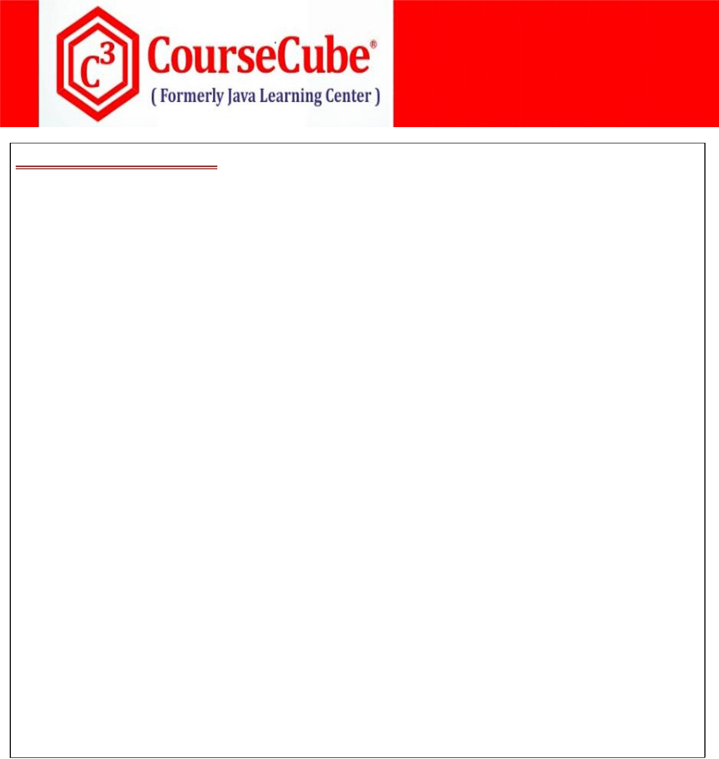

1. **JLCAppConfig.java package com.coursecube.spring;**

**import org.springframework.context.annotation.*; /\***

* **@Author : Srinivas Dande**
* **@Company : CourseCube**
* **@Website : www.coursecube.com**
* **\*/**

**@Configuration**

**public class JLCAppConfig {**

**@Bean(name="myhai")**

**public Hai createHai() {**

**Hai hai=new Hai();**

**hai.setMsg("I am Hai Bean");**

**return hai;**

**}**

**@Bean(name="myao")**

**public A createA() {**

**A ao=new A();**

**ao.setStr("I am Bean - A");**

**return ao;**

**}**

**@Bean(name="myhello")**

**public Hello createHello() {**

**return new Hello();**

**}**

**}**



**www.coursecube.com** **75** **Spring-5 Study Guide**